Ideation Phase
Brainstorm & Idea Prioritization

Date | 15 July 2026
Team ID
Project Name | Food Ordering Behaviour and Consumer Trends
Maximum Marks | 4 Marks

Brainstorm & Idea Prioritization:
Brainstorming provides a free and open environment that encourages everyone within a team to participate in the creative thinking process that leads to problem solving. Prioritizing volume over value, out-of-the-box ideas are welcome and built upon, and all participants are encouraged to collaborate, helping each other develop a rich amount of creative solutions.
Reference: https://www.mural.co/templates/brainstorm-and-idea-prioritization
Step-1: Team Gathering, Collaboration and Select the Problem Statement
Businesses in the food delivery industry generate large volumes of customer and order data but often struggle to identify customer preferences, ordering patterns, delivery performance, and revenue trends. The project aims to analyze food ordering behavior using Tableau dashboards to provide meaningful insights that support better business decisions, improve operational efficiency, and enhance customer satisfaction.
Step-2: Brainstorm, Idea Listing and Grouping
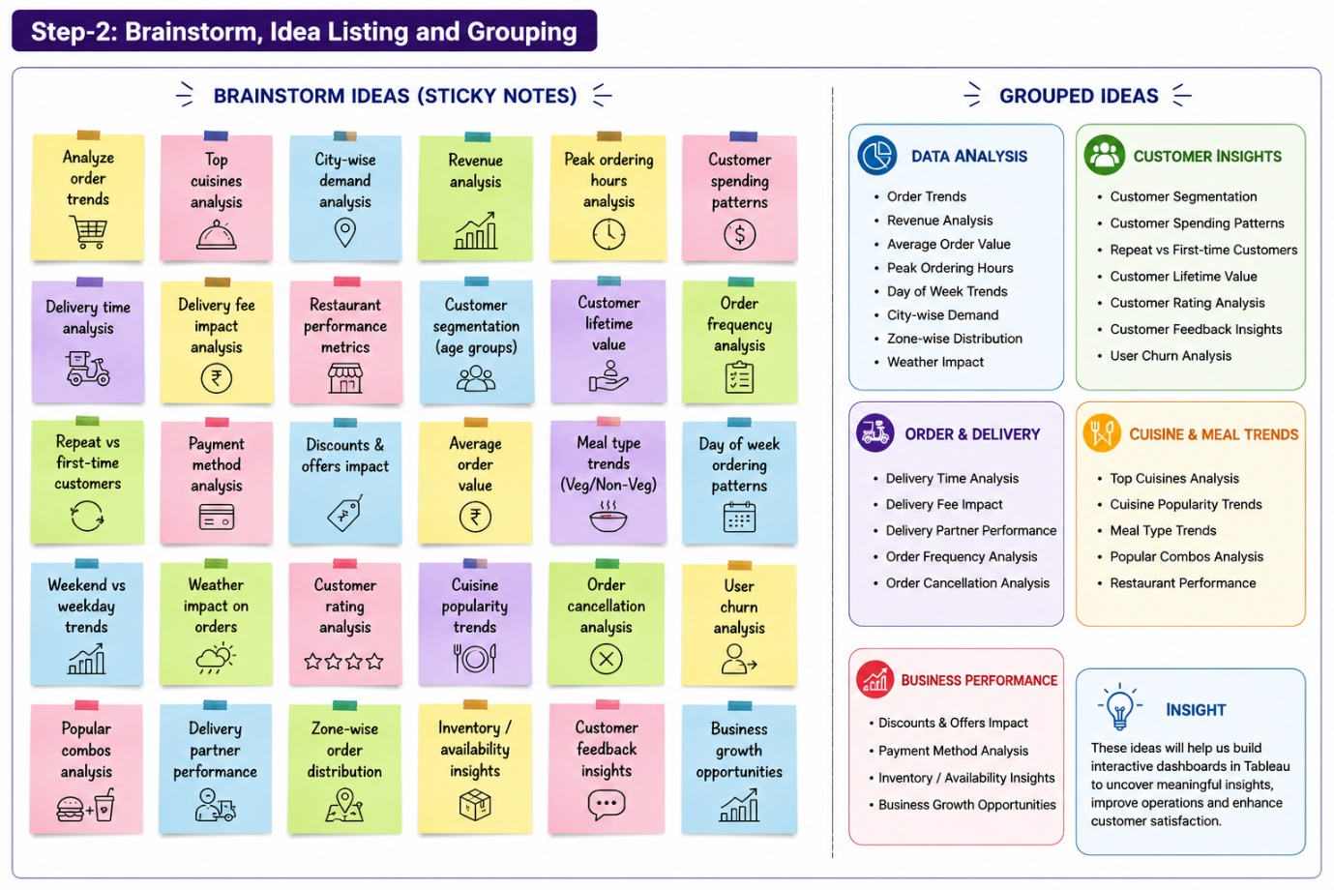

Step-3: Idea Prioritization
